<https://docs.microsoft.com/en-us/azure/active-directory/develop/quickstart-v2-aspnet-core-webapp>

Step 1) Register app

Step 2) Register return Url

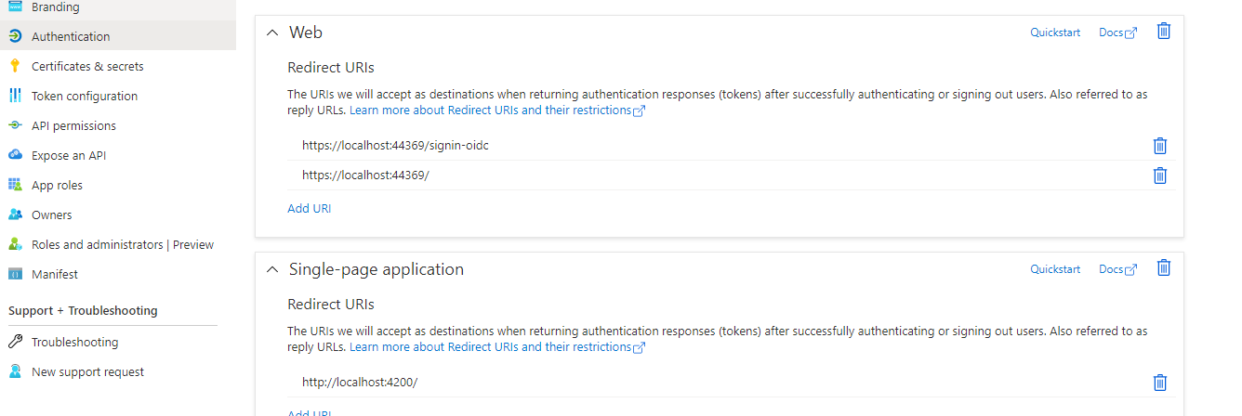

Step 3  
Project version is SDK 3.1 , So selected latest version start with 3 (3.1.17

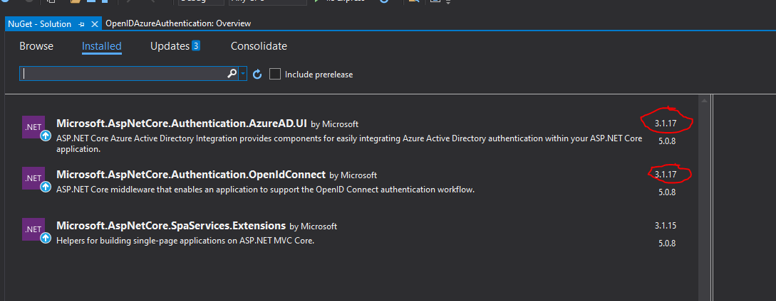

Step 3  
Enter CilentID ,Tenat id on appsettings.json

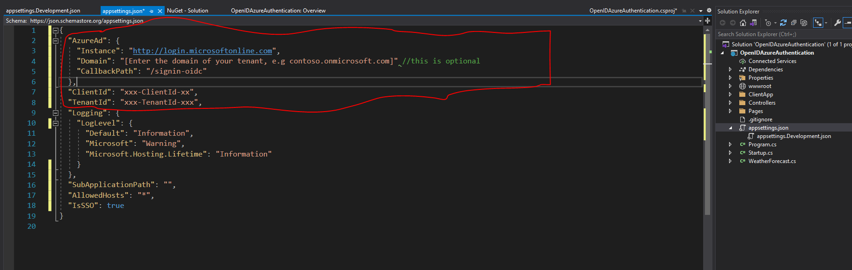

Step 4

Add these two on Startup.cs

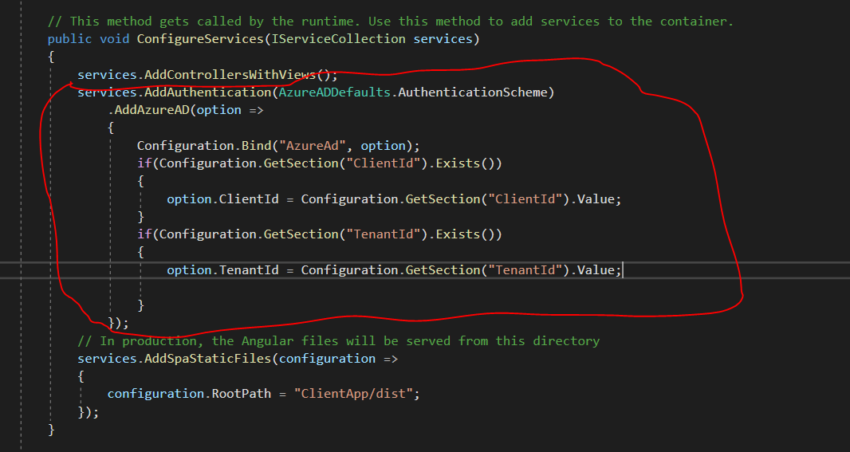

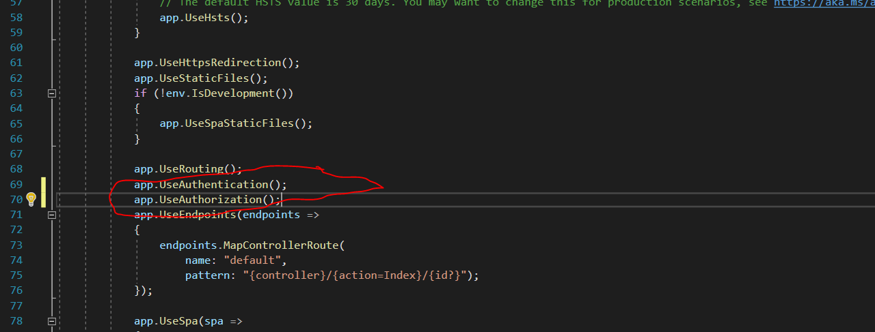

Step 5

Add this on controller

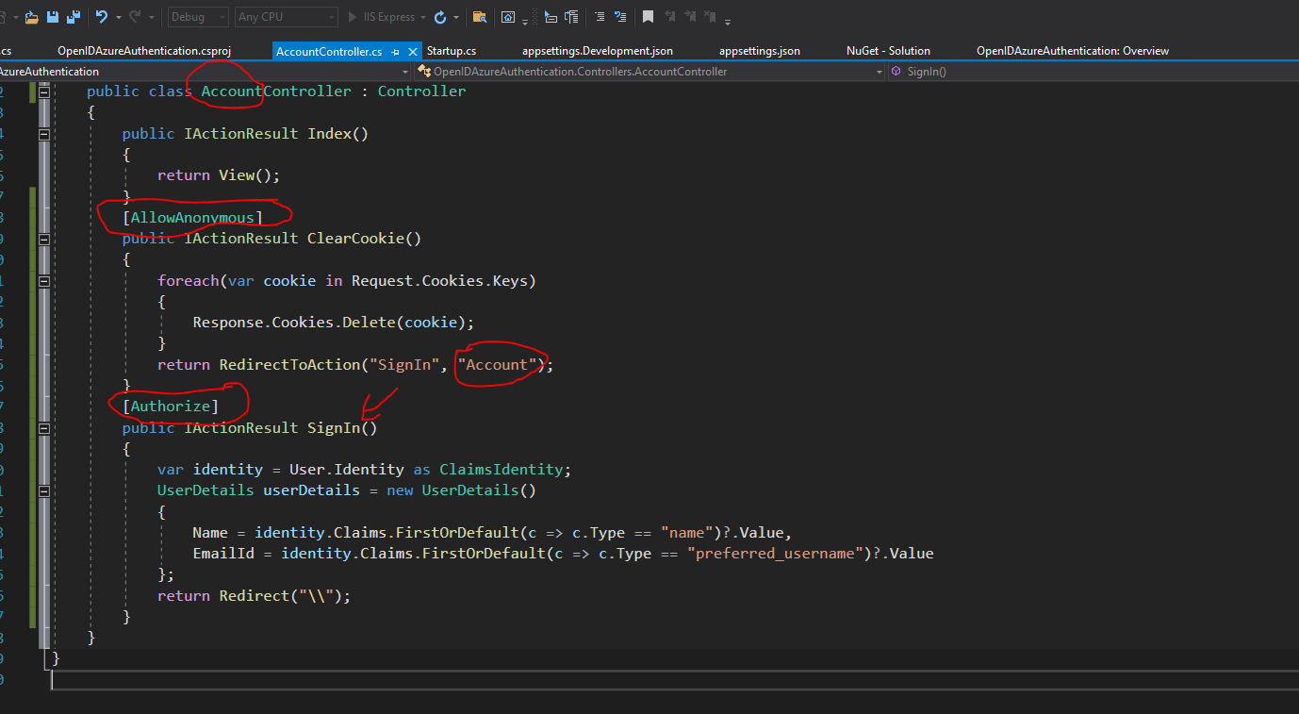

================================= CODE ===============================

Step 3 code

"AzureAd": {

"Instance": "http://login.microsoftonline.com",

"Domain": "[Enter the domain of your tenant, e.g contoso.onmicrosoft.com]" //this is optional

"CallbackPath": "/signin-oidc"

},

"ClientId": "xxx-ClientId-xx",

"TenantId": "xxx-TenantId-xxx",

Step 4 Code

services.AddAuthentication(AzureADDefaults.AuthenticationScheme)

.AddAzureAD(option =>

{

Configuration.Bind("AzureAd", option);

if(Configuration.GetSection("ClientId").Exists())

{

option.ClientId = Configuration.GetSection("ClientId").Value;

}

if(Configuration.GetSection("TenantId").Exists())

{

option.TenantId = Configuration.GetSection("TenantId").Value;

}

});

-----------------------

app.UseAuthentication();

app.UseAuthorization();

Step 5 Code

[AllowAnonymous]

public IActionResult ClearCookie()

{

foreach(var cookie in Request.Cookies.Keys)

{

Response.Cookies.Delete(cookie);

}

return RedirectToAction("SignIn", "Account");

}

[Authorize]

public IActionResult SignIn()

{

var identity = User.Identity as ClaimsIdentity;

UserDetails userDetails = new UserDetails()

{

Name = identity.Claims.FirstOrDefault(c => c.Type == "name")?.Value,

EmailId = identity.Claims

.FirstOrDefault(c => c.Type == "preferred_username")?.Value

};

return Redirect("\\");

}